Lab – 6

Classification of Polymorphism, Compile time and Run time Polymorphism, Pointers to derived class object, Virtual functions, Pure virtual functions.

1. Polymorphism is also known as dynamic linkage or late binding. Write a C++ program to implement (i) compile time polymorphism by function overloading (ii) virtual function. Hint – Use parent class and child class with functions of same name.

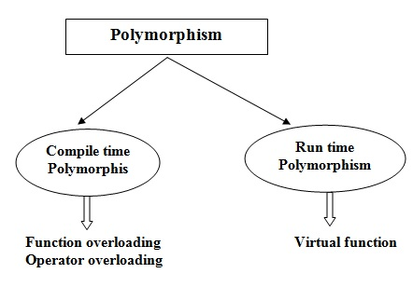

1. Write a simple base class and a child class using public mode of inheritance. Implement the arrow operator to access the member functions of both parent and child class.
2. Write C++ programs to practice & understand various pointer objects in the main function (i) Base \*b = new Base(); (ii) Base \*b = new Derived() (iii) Derived \*d = new Base() (iv) Derived \*d = new Derived().
3. Write a program to implement (i) virtual function (ii) pure virtual function
4. Verify that an abstract class can have constructors.
5. Discuss the pros-cons of polymorphism of C++ in the lab.